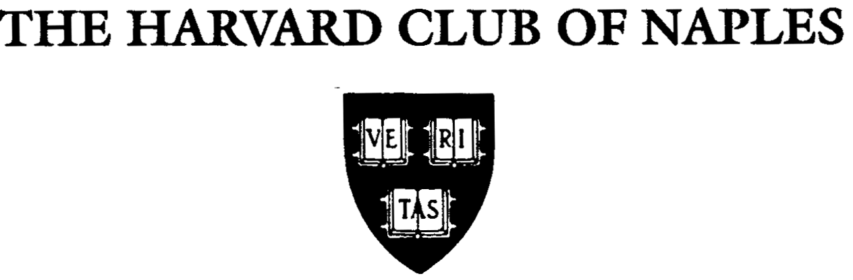

Cordially invites you to the

Special Annual Meeting and Dinner
to Celebrate the
30th Anniversary of The Harvard Club of Naples
and the
375th Anniversary of Harvard University
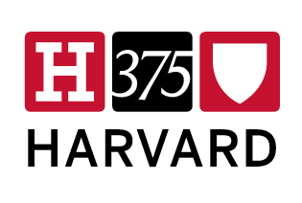

Featuring

Jane Mendillo

President & CEO, Harvard Management Company

Jane Mendillo leads the company managing Harvard University’s $32 billion portfolio consisting of the endowment and related assets. In 2008 & 2009, she was one of Forbes 100 Most Powerful Women.

Date: Thursday, February 23, 2012
Place: The Club Pelican Bay
(707 Gulf Park Drive)
Time: Reception – 6:00 PM (Cash Bar)
Dinner – 6:45 PM; Annual Meeting – 7:45 PM
Cost: $55 per person
Kindly respond by Friday, February 17, 2012.
- - - - - - - - - - - - - - - - - - - - - - - - - - - - - - - - - - - - - - - - - - - - - - - - - - - - - - - - - - - - - - - - - - - - - - - - -

Special Annual Meeting and Dinner

Thursday, February 23, 2012

Name:______________________________________________________________________

Harvard Degree/Year or Affiliation: __________________ E-mail:___________________

Name of spouse and/or Guest(s) for Name Tags:__________________________________

Number of Reservations ___________@ $55 each Total Enclosed $_____________

Please make check payable to “The Harvard Club of Naples” and return with this form in the enclosed envelope to The Harvard Club of Naples * P.O. Box 9302 * Naples, FL 34101-9302
Call Karen Lannan, Club Administrator (793-7887 or email klannan@comcast.net) if you have any questions
or for last minute reservations.

The Harvard Club of Naples
Special Annual Meeting and Dinner
Thursday, February 23, 2012
Menu at The Club Pelican Bay

Salad
Pelican Bay Salad
with Balsamic Vinaigrette & Ranch
Warm Rolls & Butter

Combined Entrée
5 oz. Filet Mignon (M.R.) with Sauce Merlot
2 Shrimp Scampi with Béarnaise Sauce at the Tables
Duchess Potato with Boursin Cheese
Chef’s Vegetable Jardiniere

Dessert
Harvard Club’s Special Red Velvet Cake
with Creamy Vanilla Frosting –
specially baked & decorated for tonight’s event

Coffee, Decaffeinated Coffee or Tea

